Adventurous Journey – Preparation and Training

1. Log into the system at [www.onlinerecordbook.org](http://www.onlinerecordbook.org)
2. Under Adventurous Journey click on **Preparation and Training**

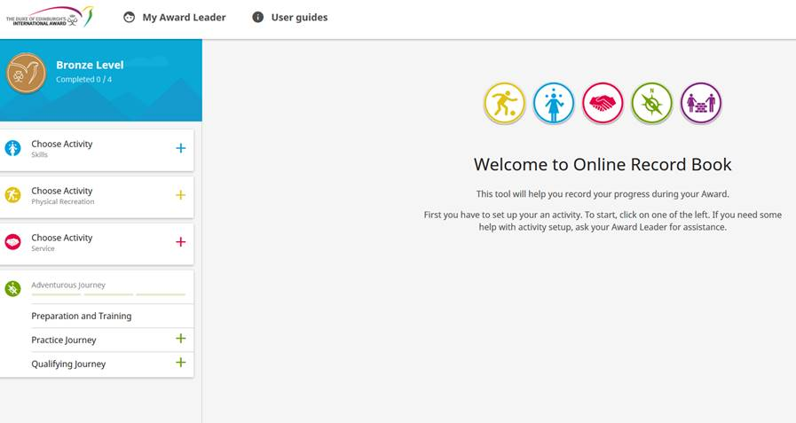

1. Under Activity select the date that the training was done and check the box. Click **UPDATE** at the bottom of the page to save your records.

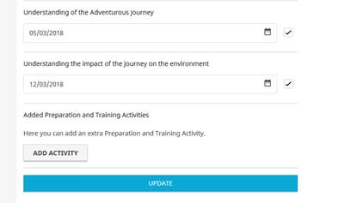

1. If you completed the training through an Accredited Award Provider, upload the certificate of completion under Files. If you do not have a certificate of completion, please speak to your Award Leader.

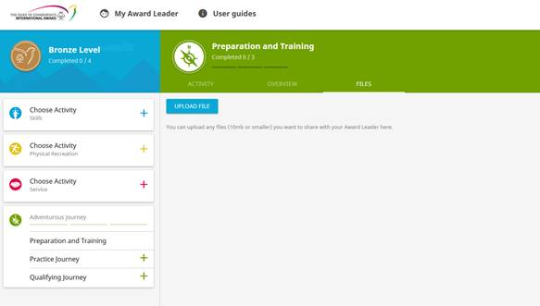

1. Once all the modules have been completed you can click the **SEND REPORT**

